**Type of Machine Learning:**

1. Supervised Learning
2. Unsupervised Learning
3. Reinforcement Learning
4. Semi-Supervised Machine Learning

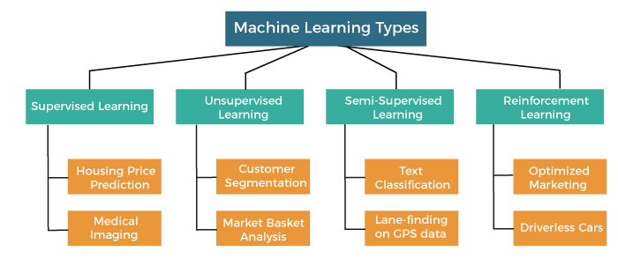

## **Supervised Machine Learning**

* Classification
* Regression

1. **Classification**

* Random Forest Algorithm
* Decision Tree Algorithm
* Logistic Regression Algorithm
* Support Vector Machine Algorithm

1. **Regression**

* Simple Linear Regression Algorithm
* Multivariate Regression Algorithm
* Decision Tree Algorithm
* Lasso Regression
* Gradient Boosting
* Neural Networks
* Naive Bayes

## **Unsupervised Machine Learning**

* Clustering
* Association

1. **Clustering**

* K-Means Clustering algorithm
* Mean-shift algorithm
* DBSCAN Algorithm
* Principal Component Analysis
* Independent Component Analysis
* Gaussian Mixture Models (GMM)
* Hierarchical Clustering
* t-SNE
* Autoencoders

1. **Association**

* Apriori Algorithm
* Eclat
* F-P Growth Algorithm

## **Reinforcement Learning Algorithms:**

* Q-Learning
* Deep Q Networks (DQN)
* Policy Gradient Methods
* Actor-Critic Methods
* Proximal Policy Optimization (PPO)
* Monte Carlo Tree Search (MCTS)

## **Natural Language Processing Algorithms:**

* Word2Vec
* GloVe (Global Vectors for Word Representation)
* Recurrent Neural Networks (RNN)
* Long Short-Term Memory (LSTM)
* Transformer Models (e.g., BERT, GPT)
* Named Entity Recognition (NER)
* Sentiment Analysis

**Deep Learning Architectures:**

* Convolutional Neural Networks (CNN)
* Recurrent Neural Networks (RNN)
* Long Short-Term Memory (LSTM)
* Gated Recurrent Units (GRU)
* Transformer Models
* Generative Adversarial Networks (GAN)
* Variational Autoencoders (VAE)
* Siamese Networks

**Bayesian Algorithms:**

* Bayesian Networks
* Markov Chain Monte Carlo (MCMC)

**Fuzzy Logic Algorithms:**

* Fuzzy C-Means Clustering
* Fuzzy Inference Systems